Projectile Motion

PHYS 211L – H02

Tuesday 10:05am – 12:05pm

Abstract

We investigated the initial velocity of a projectile by measuring the projectile’s range and compared it to the initial velocity by timing the projectile as it crossed a known distance. We also investigated the effect that the launch angle of the projectile has on its range. We found that the range is greatest when the launch angle is 45 degrees, and that the initial velocity of the projectile was (5.926 ± 0) m/s when using the distance over time method, and (5.148 ± 1.039) m/s when using the range equation.

Introduction/Background

The idea of projectile motion is one of significance in many areas of the physical world. Before the Italian physicist Galileo revolutionized the topic with his studies, it was widely believed that a projectile in motion would travel a certain distance in a straight line before losing its “impetus” and fall straight down. This idea of an invisible force, “impetus”, was popularized by Aristotle.

It wasn’t until Galileo observed that projectiles actually travel along a curved path, that he began to change the way we look at projectile motion. Galileo realized that the path of a projectile could be broken into a horizontal and a vertical component that could be used together to describe its motion. Through further studies, the physicist discovered that the path of the projectile was identical to one previously and extensively studies by the Greeks, a parabola. On the course of this parabola, the vertical and horizontal components of the object’s motion are independent of one another. Using this knowledge, Galileo was able to precisely and mathematically calculate the parabolic shape of a projectile’s motion.

Procedure

Our equipment includes a caliper, a ballistic pendulum, an angle apparatus, a clamp, an electronic timer attached to a photogate, a meter stick, an adjustable platform, a sheet of carbon paper, and a metal ball.

Metal ball

Carbon paper on top of an adjustable platform

Ballistic Pendulum with photogate attached to timer

With this setup, we launched the ball from angles of 5°, 15°, 30°, 45°, 60°, and 70°. We made sure that the ball landed on the surface at the same height from which it was launched in order for our equations to be valid. We measured the range using a meter stick, and the time the ball spent blocking the gate’s sensor using the electronic stopwatch. Then, we measured the width of the ball using the caliper and determined that the width is 0.016 meters. With this data, we now have the range and initial velocity at each launch angle.

Results/Analysis/Physics

Going into this experiment, we know from basic kinematics and trigonometry that the equation for the horizontal distance the projectile travels, or in other words, the range, is $R=\left(\frac{v^{2}}{g}\right)*sin⁡(2θ)$. $v$ is the magnitude of the initial velocity, $g$ is the acceleration due to gravity, and $θ$ is the angle from which the projectile is launched. In our experiment, we had measured the range and magnitude of the initial velocity and were given the launch angles. As a result, we used this equation in three different ways. First, we used our given and measured values for $θ$ and $v$ respectively to calculated the predicted values of $R$.Second, we used our given and measured values for $θ$ and $R$ respectively in order to solve for $v$. Then, we used our original measurements for $v$ along with the same measured values of $R$ to calculate $θ$. We then calculated our uncertainties for $v$ and $θ$ by finding the greatest deviation from the average, and we found our uncertainty for the range using:

$∆R=\sqrt{\left({\left(\left(\frac{2v}{g}\right)∆vsin\left(2θ\right)\right)}^{2}+{\left(\left(\frac{v^{2}}{g}\right)∆θ2\cos\left(2θ\right)\right)}^{2}\right)}$, where $∆v$ is our uncertainty for $v$ and $∆θ$ is our uncertainty for $θ$.

Range and Time at Launch Angle of 5° Range and Time at Launch Angle of 15°

|  |  |
| --- | --- |
| Range (m) | Time (s) |
| 0.315 | 0.0027 |
| 0.285 | 0.0027 |
| 0.300 | 0.0027 |
| 0.305 | 0.0027 |
| 0.290 | 0.0027 |

|  |  |
| --- | --- |
| Range (m) | Time (s) |
| 1.40 | 0.0027 |
| 1.45 | 0.0027 |
| 1.43 | 0.0027 |
| 1.41 | 0.0027 |
| 1.41 | 0.0027 |

Range and Time at Launch Angle of 30° Range and Time at Launch Angle of 45°

|  |  |
| --- | --- |
| Range (m) | Time (s) |
| 2.59 | 0.0027 |
| 2.62 | 0.0027 |
| 2.61 | 0.0027 |
| 2.58 | 0.0027 |
| 2.60 | 0.0027 |

|  |  |
| --- | --- |
| Range (m) | Time (s) |
| 2.96 | 0.0027 |
| 2.92 | 0.0027 |
| 2.95 | 0.0027 |
| 2.95 | 0.0027 |
| 2.92 | 0.0027 |

|  |  |
| --- | --- |
| Range (m) | Time (s) |
| 1.8796 | 0.0027 |
| 1.83 | 0.0027 |
| 1.82 | 0.0027 |
| 1.84 | 0.0027 |
| 1.83 | 0.0027 |

Range and Time at Launch Angle of 60° Range and Time at Launch Angle of 70°

|  |  |
| --- | --- |
| Range (m) | Time (s) |
| 2.58 | 0.0027 |
| 2.56 | 0.0027 |
| 2.57 | 0.0027 |
| 2.59 | 0.0027 |
| 2.58 | 0.0027 |

Initial Speed at Each Launch Angle (using v = d/t where d is the width of the ball 0.016m)

|  |  |  |  |  |  |  |  |
| --- | --- | --- | --- | --- | --- | --- | --- |
| Launch Angle (degrees) | Trial 1 (m/s) | Trial 2 (m/s) | Trial 3 (m/s) | Trial 4 (m/s) | Trial 5 (m/s) | Average (m/s) | Uncertainty (m/s) |
| 5 | 5.926 | 5.926 | 5.926 | 5.926 | 5.926 | 5.926 | 0 |
| 15 | 5.926 | 5.926 | 5.926 | 5.926 | 5.926 | 5.926 | 0 |
| 30 | 5.926 | 5.926 | 5.926 | 5.926 | 5.926 | 5.926 | 0 |
| 45 | 5.926 | 5.926 | 5.926 | 5.926 | 5.926 | 5.926 | 0 |
| 60 | 5.926 | 5.926 | 5.926 | 5.926 | 5.926 | 5.926 | 0 |
| 70 | 5.926 | 5.926 | 5.926 | 5.926 | 5.926 | 5.926 | 0 |

Initial Speed at Each Launch Angle (using the range equation and solving for v)

|  |  |  |  |  |  |  |  |
| --- | --- | --- | --- | --- | --- | --- | --- |
| Launch Angle (degrees) | Trial 1 (m/s) | Trial 2 (m/s) | Trial 3 (m/s) | Trial 4 (m/s) | Trial 5 (m/s) | Average (m/s) | Uncertainty (m/s) |
| 5 | 4.218 | 4.013 | 4.117 | 4.151 | 4.048 | 4.109 | 0.109 |
| 15 | 5.241 | 5.334 | 5.297 | 5.260 | 5.260 | 5.278 | 0.056 |
| 30 | 5.417 | 5.448 | 5.437 | 5.406 | 5.427 | 5.427 | 0.021 |
| 45 | 5.389 | 5.352 | 5.380 | 5.380 | 5.352 | 5.371 | 0.019 |
| 60 | 5.406 | 5.385 | 5.396 | 5.417 | 5.406 | 5.402 | 0.017 |
| 70 | 5.356 | 5.285 | 5.270 | 5.299 | 5.285 | 5.299 | 0.057 |

Each Calculated Angle Compared to Each Given Angle

|  |  |  |  |  |  |  |  |
| --- | --- | --- | --- | --- | --- | --- | --- |
| Given Launch Angle (radians) | Trial 1 (radians) | Trial 2 (radians) | Trial 3 (radians) | Trial 4 (radians) | Trial 5 (radians) | Average (radians) | Uncertainty (radians) |
| 0.177 | 0.0441 | 0.0398 | 0.0420 | 0.0427 | 0.0405 | 0.0418 | 0.0023 |
| 0.5 | 0.201 | 0.209 | 0.205 | 0.202 | 0.202 | 0.204 | 0.005 |
| 0.866 | 0.404 | 0.411 | 0.409 | 0.402 | 0.406 | 0.406 | 0.005 |
| 1 | 0.487 | 0.477 | 0.484 | 0.484 | 0.477 | 0.482 | 0.005 |
| 0.866 | 0.402 | 0.398 | 0.400 | 0.404 | 0.402 | 0.401 | 0.003 |
| 0.643 | 0.276 | 0.268 | 0.267 | 0.270 | 0.268 | 0.270 | 0.006 |

Uncertainty in the Predicted Range at Each Launch Angle

|  |  |
| --- | --- |
| Launch Angle (degrees) | Uncertainty (meters) |
| 5 | 0.0162 |
| 15 | 0.0310 |
| 30 | 0.0179 |
| 45 | 0 |
| 60 | 0.0107 |
| 70 | 0.0329 |

Theoretical Range at Each Launch Angle

|  |  |
| --- | --- |
| Launch Angle (degrees) | Theoretical Range (meters) |
| 5 | 0.622 |
| 15 | 1.79 |
| 30 | 3.10 |
| 45 | 3.58 |
| 60 | 3.10 |
| 70 | 2.30 |

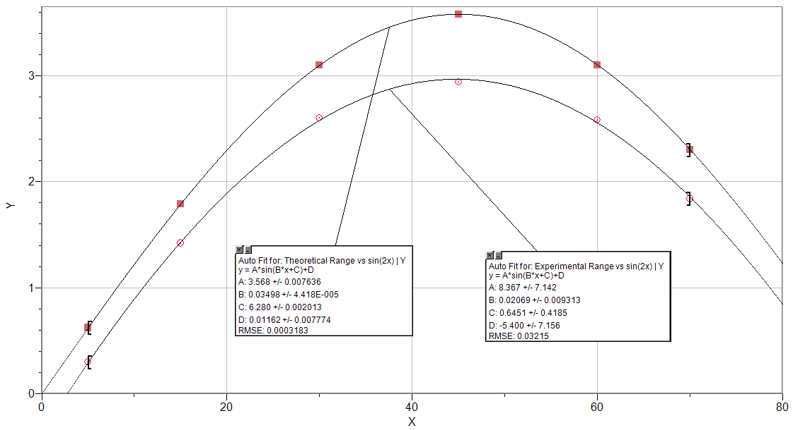

Free Body Diagram of the Projectile in Flight

·

Fgravity

The force of gravity is constant

Conclusion

[*What was learned*] From this lab we were able to confirm Galileo’s studies of projectile motion. We were able to experience first-hand the parabolic nature of the motion of a projected object. The lab showed that the force of gravity on an object is constant throughout the motion of a projectile. It also proved that the horizontal and vertical components of an object’s motion are independent of one another. These components can be used to mathematically calculate the precise path an object will undertake once launched at a certain angle with a given speed. Using the velocity, kinematics, and trigonometry, we are able to determine the horizontal distance the projectile will travel before falling to the ground.

[*Uncertainties*] Our recorded results in this experiment were moderately accurate to the expected calculated findings. The primary source of error in the system would be the result of air resistance. Because of an opposing frictional force acting on the object as it traveled through the air, the expected distance covered by the ball will always fall slightly short. The only way to avoid such a situation is to place the entire projectile motion system in a perfect vacuum.

[*First Universal Question*] The data we recorded differed somewhat substantially from the calculated results; however, this was to be expected due to the nature of air resistance. The margin of error would at times be as high as 18% from the “perfect”, or ideal, result. In real world application, an ideal parabola is nearly impossible to achieve from the motion of a particle due to the presence of outside forces.

[*Second Universal Question*] The phenomenon of projectile motion is experienced in everyday life. In something as simple as a game of catch, the principles discovered by Galileo are tested and proven over and over again. The ball is launched at an angle from the horizontal and is given a velocity component in the x and y direction. The force of gravity in the negative y direction, which is entirely independent from the x component, gradually forces the ball back down into the hands of the catcher. This process is also present when you fire a bullet into the air. Despite its intensely higher immediate speed, it will reach the ground at the same time as the thrown ball if both are launched parallel to the horizontal because the x and y components are independent of one another. Both examples will have a projectile fly through the air in a parabolic path.

Lab Questions

1. Our initial velocity from the timer was always the same, and always greater than the velocity we calculated from the range and firing angle data.
2. Graph 1 tells me that as the launch angle increases from 0 to 45 degrees, the range increases up to a certain value, and then from 45 to 70 degrees, the range decreases. The graph is a good representation of the data for all firing angles.
3. Some mechanical energy is lost due to air resistance. This is because the projectile does work on the air.
4. To get the greatest range, the launch angle should be 45 degrees. Our data and calculations support this. Another way to think about it is by looking at the range as a function of sin(2x). If you plug 45 degrees into that equation, you get sine of 90 degrees which is 1. Since 1 is the largest value that sine can be, the range will be at its largest when the launch angle is 45 degrees.